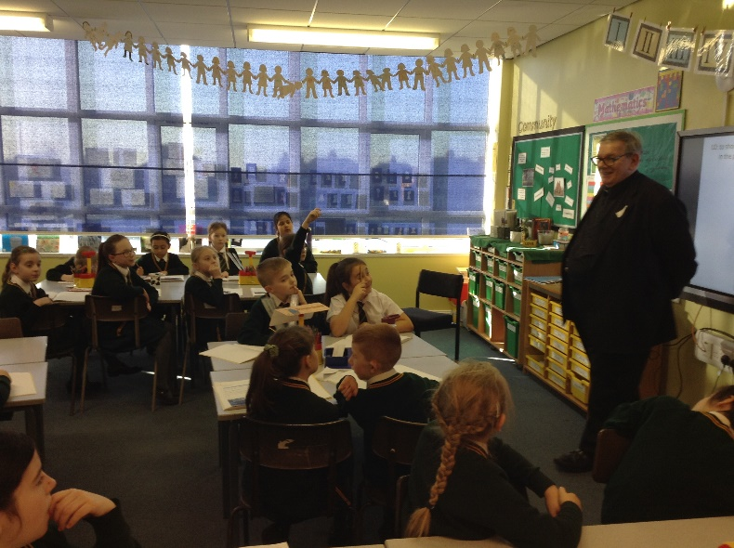
On Tuesday 21st January 2020, Fr Elliott came to visit Year 4 to talk about his role as priest in our parish (Community LF3)

The following week Year 4 visited Fr Elliott at church. He explained the symbols of a Catholic funeral mass and what they mean. (Community LF6)
