Come and join us for Prayer.
Tuesday lunchtimes
12.30-12.50
Lunchtime Prayer
Every Tuesday lunchtime, our prayer room is open for private/shared prayer. Our God Squad invite children across all age groups to join them in prayer. At certain times, this is led by the children; other times it is a space where they can come for personal prayer and reflection.

Lunchtime Prayer – October
Throughout October, our God Squad led prayer time with the Sorrowful Mysteries of the Rosary. All children were invited to join in our outside classroom. It was wonderful to see so many children choosing to dedicate their lunchtimes to Our Lady.

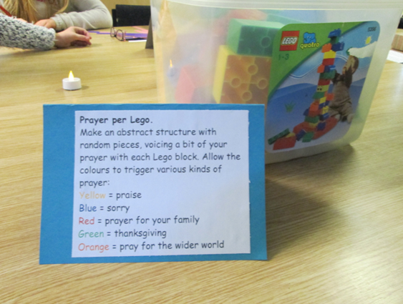
Lunchtime Prayer Group – Advent
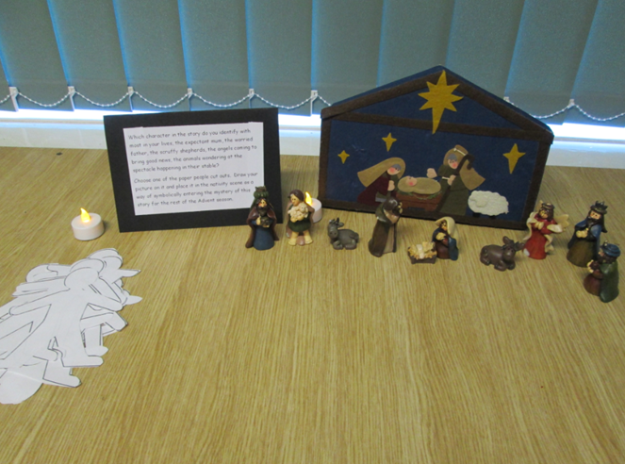
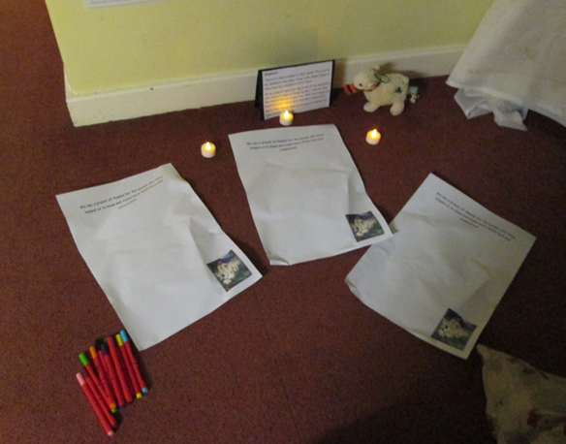
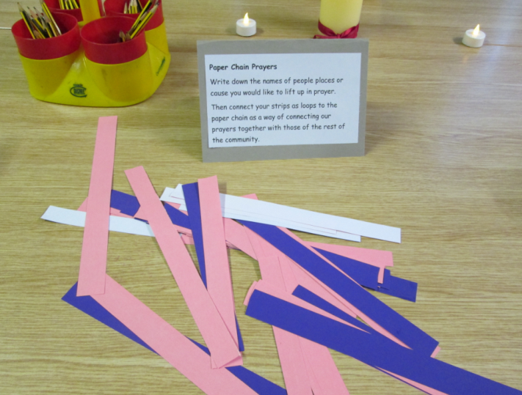
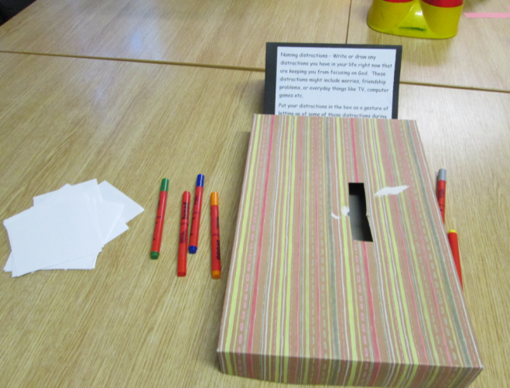

During Advent, our weekly prayer time focused on joyful waiting.

Lunchtime Prayer Group – Spring
Our weekly lunchtime prayer group centred on Guided Meditations for children. In the year of ‘The God who Speaks’ our meditations were scripture based. The children were able to take time out of a busy school day, to relax, wrap themselves in calming music and be enveloped by God’s words in scripture.
They were encouraged to open their hearts to God. When distracting thoughts came, just to return to the scripture without judging, but simply return to the promise of Christ's peace and presence.

Lunchtime Prayer Group – Lent
Our weekly lunchtime prayer group centres on the Stations of the Cross. We focused on 2 stations each week, following the journey of Our Lord, Jesus Christ from being condemned to death through to being laid in the tomb.
Together, we hear from scripture, pray and reflect on the meaning in our lives today. How do we pick up the cross of Jesus?

