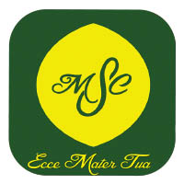 | School to Parish Newsletter  We hope that you are well and we continue to pray for you all.  As always, our children have been working extremely hard and are a credit to the School, Parents and our Parish. We would like to share with you, once again, some of the things we have been getting up to.
For with God, nothing is impossible. Luke 1:37
We make new and happy memories together.
We are caring, kind and amazing just like Jesus.
Each of us is an important part of the jigsaw, which makes up our school family.
We are all special and respect each other’s differences.
We never give up on our journey to success.

This term we have learnt about the community and each year group has focused on a specific aspect of this. Reception class focused on celebrations, Year 1 looked at special people, Year 2 learnt about the Bible and some of the stories from the Old and New Testament. Year 3 focused on Journeys, Year 4, Community, Year 5 was Mission and Year 6 was sources.
We also focused on two other religions which were Islam and Judaism.

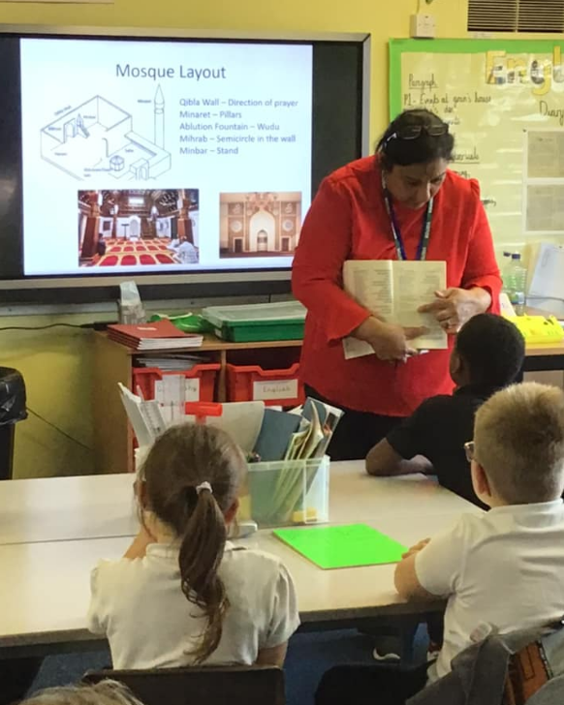
Islam Week.To support our teaching during our
multi-faith week, focusing on Islam; we arranged for a visit from Mehj Dar and Mooda Raja from the multicultural centre. Each class took part in a workshop linked to their study focus.

Reception | Made prayer beads | Year 3 | Designed a mosque
Year 1 | Designed Islamic bookmarks | Year 4 | Bookmark of Allah’s names
Year 2 | Made a prayer timetable - clocks | Year 5 | Made Pakora’s which would eaten at Eid celebrations
 |  | Year 6 | Made a Zakat box

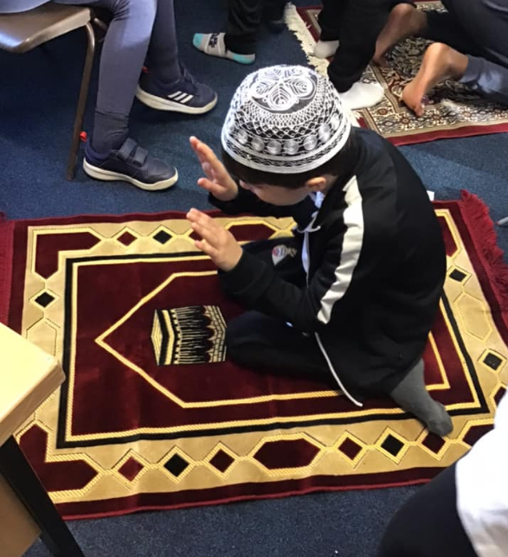

In December, we had a visit from Rita McManus who is our CAFOD representative. We learnt how we can make a difference to our global neighbours and how small gifts can make a big difference and help transform the lives of families living in poverty. We decided to have a ‘Christmas Jumper’ day, each child wore their jumper and made a donation towards CAFOD. As always, our families were so generous and we managed to make several purchases for those less fortunate than ourselves.
Thanks to the generosity, we purchased a goat, chicken. water for a family, a stove and some bees.
We received a lovely message of thanks from our CAFOD representative:

Dear parents and carers of Our Lady of Mount Carmel School,
I am so glad to be able to send this message of thanks and appreciation to you. I am a schools’ volunteer for CAFOD and am frequently invited to give assemblies or workshops to your children, telling them about the work of CAFOD around the world. One of the reasons I love coming into your school is the enthusiasm, understanding and compassion of the children. They have an amazing grasp of the message of Jesus, which is, put simply, to love one another. Their and your support for CAFOD makes a truly life-changing difference to families who have so little. I was astonished when I learned that the children had raised a magnificent £94 at Christmas, a time when many families in our own local community, themselves, face hardship. So, although it seems an inadequate response, may I say “Thank You” on behalf of the families and communities whose lives your generosity has transformed.
I wish you health and happiness in the new year. God bless you.
Rita McManus

This term, we will begin to prepare ourselves for the most important event in the Church’s calendar – Easter. On Ash Wednesday a group of our children will attend the Parish Mass and receive ashes from Father Elliott. They will also be given ashes to deliver to the children back at school in two short liturgies.
A huge thank you to Father Elliott who has agreed to our children attending Parish Mass once again. It has been a difficult time due to Covid but thankfully things are beginning to return to normality and we can begin to join with you to celebrate.

Year Groups attending Mass
Thursday 24th February | Year 3 attending Parish Mass 9:30
Wednesday 2nd March | Group of children to attend Parish Ash Wednesday Mass 9:30
Thursday 10th March | Year 2 Parish Mass 9:30
Thursday 17th March | Year 4 attending Parish Mass 9:30
Thursday 24th March | Year 1 attending Parish Mass 9:30
Thursday 31st March | Year 6 attending Parish mass 9:30
Thursday 7th April | Reception and Year 5 attending Parish Mass 9:30

- 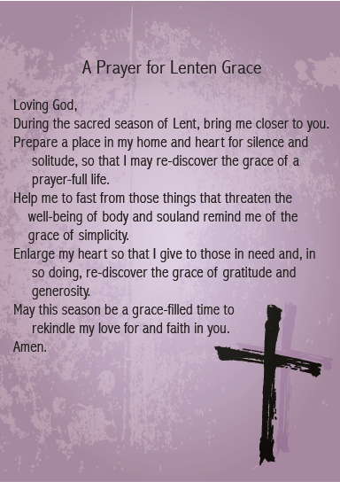

If any of you would like to volunteer to support our children through visits to school praying with our children or being involved in RE lessons, then please contact either Jane Hayes or Sharon Matthews;
class2@olmcprimaryschool.co.uk or class3a@olmcprimaryschool.co.uk

