School to Parish Newsletter
Summer 2022
As we welcome our children back to school for the summer term, we are thankful that we have had a year without any disruptions. We worked hard last term and enjoyed our preparations for the special time in our liturgical calendar, Easter.
We pray for each one of you and have enjoyed celebrating Mass with some of you each week.
For with God, nothing is impossible. Luke 1:37
We make new and happy memories together.
We are caring, kind and amazing just like Jesus.
Each of us is an important part of the jigsaw, which makes up our school family.
We are all special and respect each other’s differences.
We never give up on our journey to success.

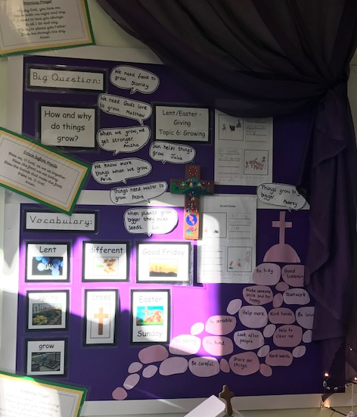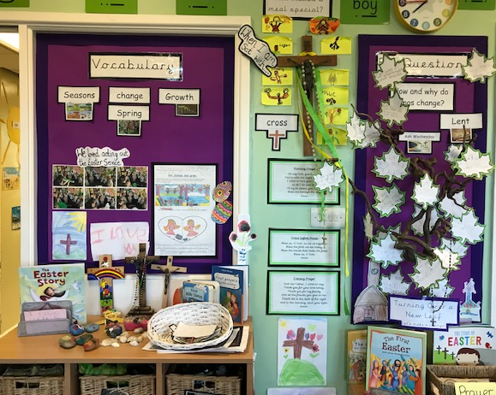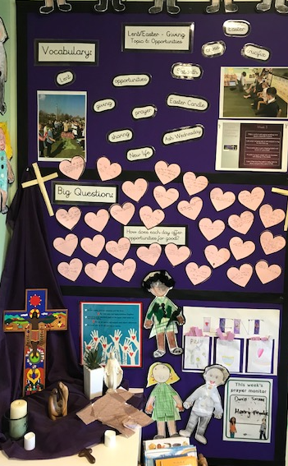
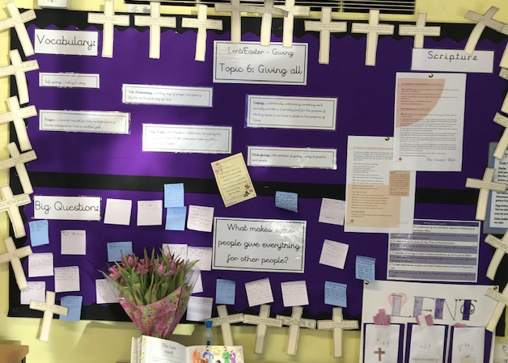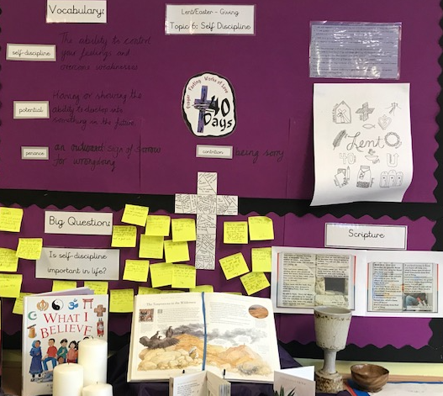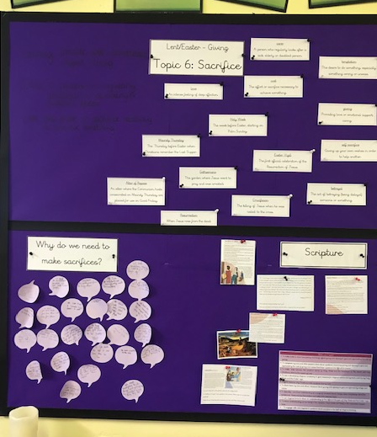
During the Spring term we learnt about the Eucharist and then began the very special topic of Lent. Alongside the weekly RE lessons, we also took part in Lenten services within school and some fundraising activities.
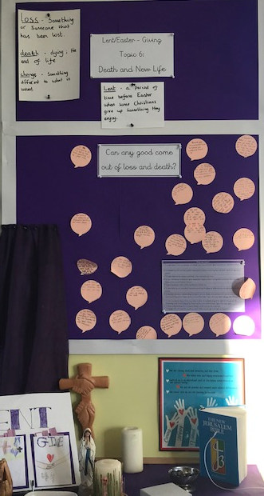

On Ash Wednesday, our ‘God Squad’ attended the Parish Mass where they received ashes. Father Elliott kindly sent some of the ashes back to school to distribute to the rest of the children. We had a lovely service which was led by the God Squad. This was the perfect start to our Lenten journey.
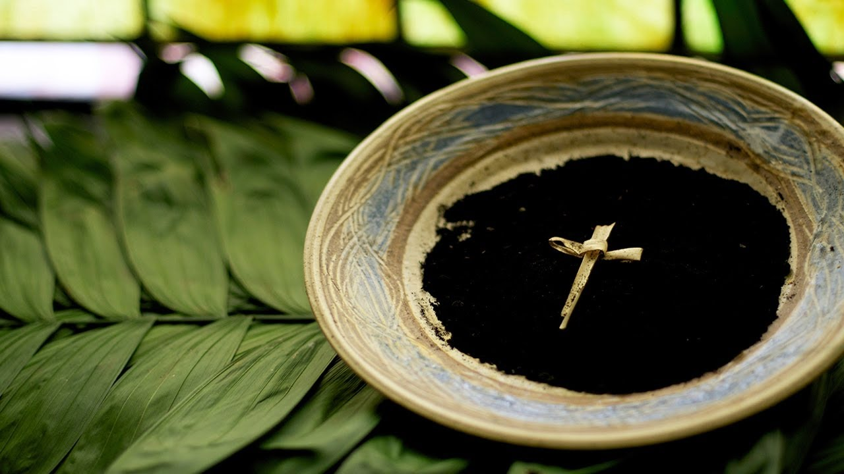

Once again, we had a collection for the local food bank. We asked our children to bring an item of food into school and couldn’t believe the response. We managed to collect enough food to fill an entire van. The food collected will help those in need in the Intake area.
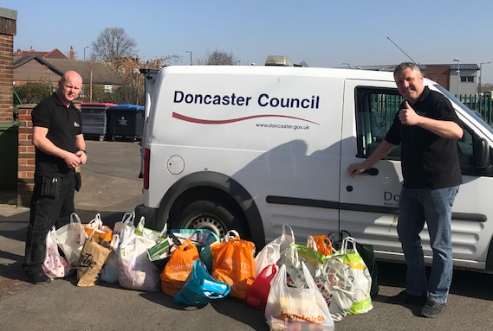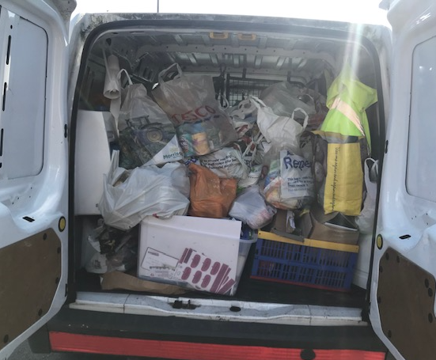
In addition to this we also had a non-uniform day to raise money for the ‘Good Shepherd’ appeal. We are so grateful to our parents and children for their kindness and generosity.
This term, we will be learning about Pentecost, Reconciliation and the Universal Church. The Universal Church is a lovely topic that encourages the children to think about themselves as global citizens. We think about how we can help those around us, how we can help to look after our world, and we also make links with CAFOD.
Last term each of our classes had the opportunity to attend Mass on a Thursday morning. Father Elliott has once again agreed to us doing this. Our children really enjoyed joining the parish and look forward to doing this once again.

Year Groups attending Mass
Thursday 12th May | Year 3 attending Parish Mass 9:30
Thursday 19th May | Year 6 attending Parish Mass 9:30
Thursday 26th May | Year 4 Parish Mass 9:30
Thursday 9th June | Year 1 attending Parish Mass 9:30
Thursday 16th June | Reception attending Parish Mass 9:30
Thursday 23rd June | Year 2 attending Parish mass 9:30
Thursday 14th July | Whole School Mass

Thank you to Bernadette Sykes who gave up her time to join us for some of our RE lessons. The children really enjoyed sharing their knowledge and learning with her.
If there are any of you who would also like to volunteer to support our children through visits to school, praying with our children or being involved in RE lessons, then please contact either Jane Hayes or Sharon Matthews.
class2@olmcprimaryschool.co.uk or class3a@olmcprimaryschool.co.uk

